The following items need your sponsorship
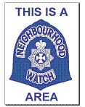
Your sponsorship is needed to purchase more Neighbourhood Watch Area signs
The last were ordered November 2009 and 90 signs cost £570.40 (including carriage and VAT ,police logo to change))
To cater for the re-launch and demand we will need to purchase at least this amount every year.
If you feel that you can help. please contact:
David Colledge, Treasurer, WSNHWA on our email address: wsnhwa@virginmedia.com.

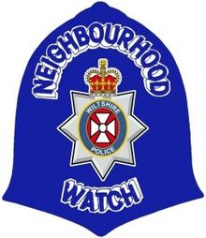
Your sponsorship is needed to purchase more Neighbourhood Watch Blue Helmet window stickers
This sticker has always been used by Wiltshire NHW, all other groups use the round, yellow, black sticker and as we have run out of our normal one we are having to hand the yellow one.!
Its not that we oppose change, but we wish to stand out from the rest, we have received many requests from our NHW co-ordintors for this sticker, so we have deceided to put it out to sponsorship.
Please support us or if not us, support Wiltshire.
The current cost is £1000.00 for 5,000. (90mm x 90mm) stickers. In March we have 46000 households in our 3600 schemes across Wiltshire and more join each month.
If you feel that you can help in anyway,any Printers out there? please contact:
David Colledge, Treasurer WSNHWA wsnhwa@virginmedia.com

